🤖 AI Prompt Engineering Section
Prompt 1: Career Advisor
Purpose: Get career guidance.
Prompt:
Act as an expert IT career counselor. Analyze a student's interests in coding and problem-solving. Recommend the most suitable IT career path, required skills, learning roadmap, and future job opportunities.
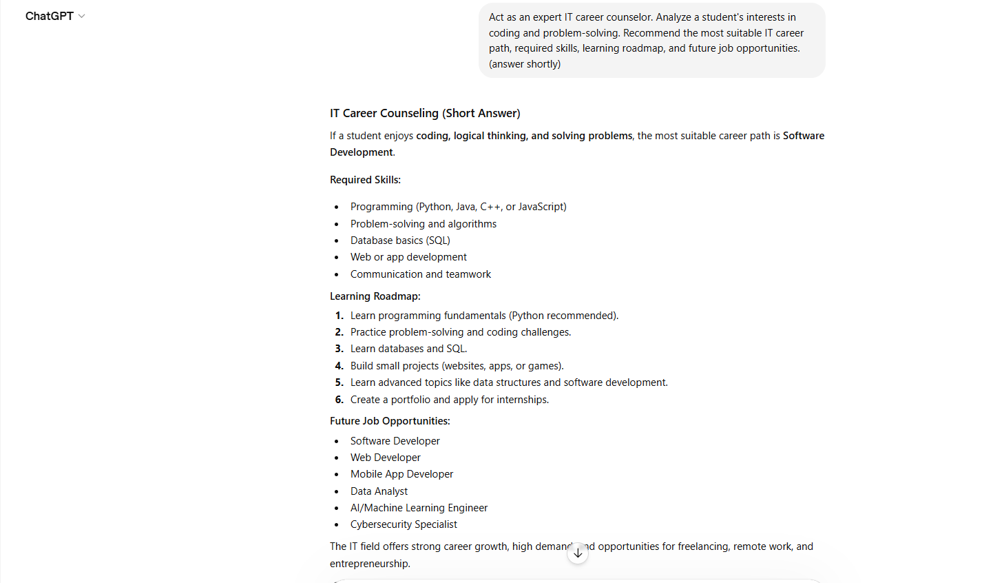
Output:
Prompt 2: CV Generator
Purpose: Create a professional CV.
Prompt:
Act as a professional resume writer. Create a one-page CV for a beginner IT student with skills in Excel, Python, GitHub, Canva, and ChatGPT.
Output:
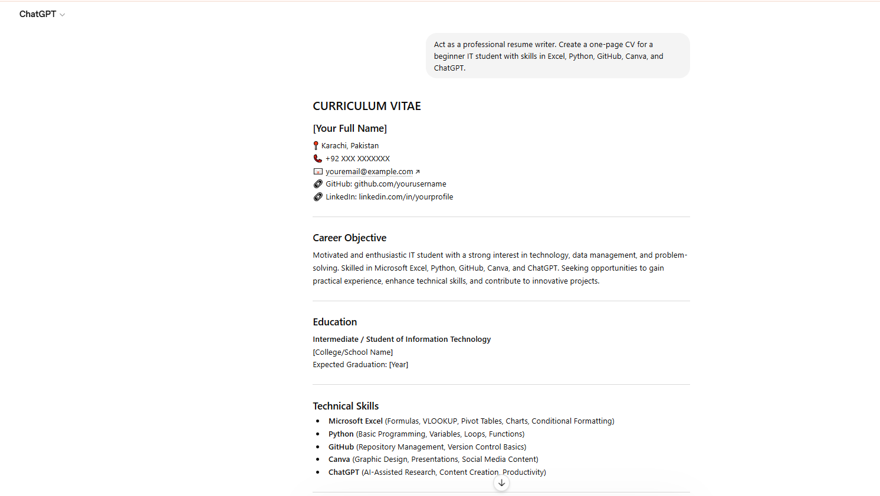

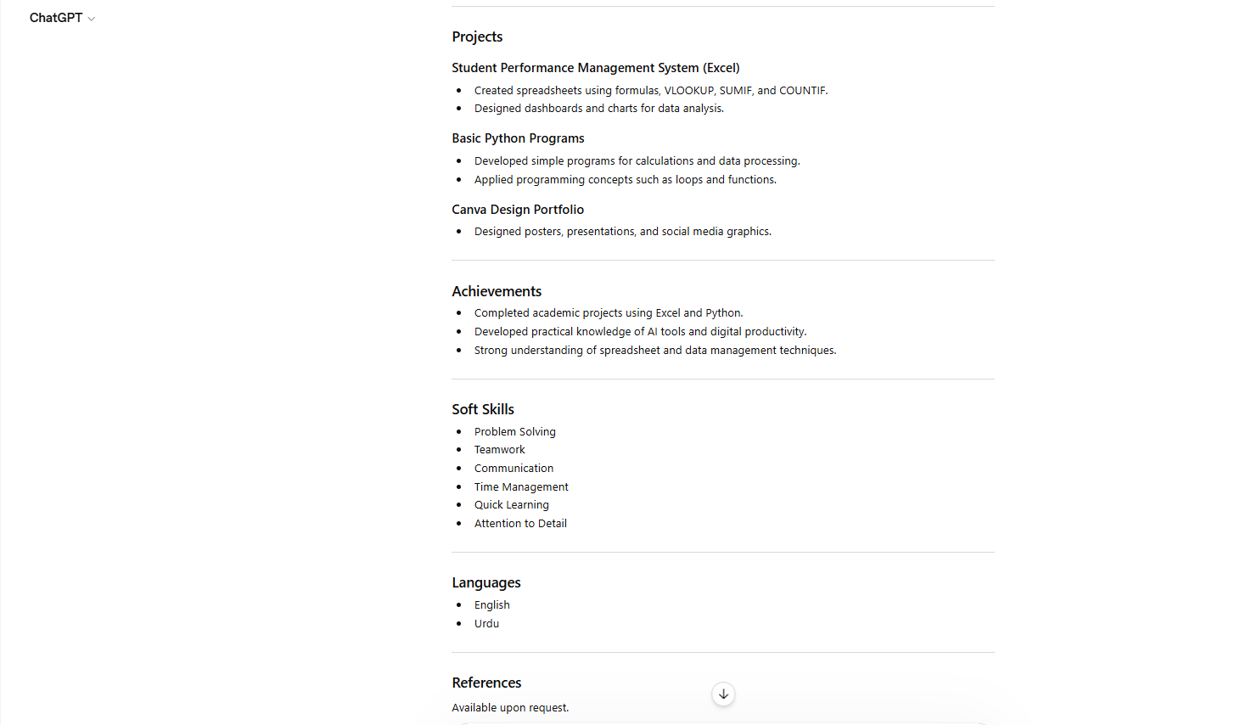

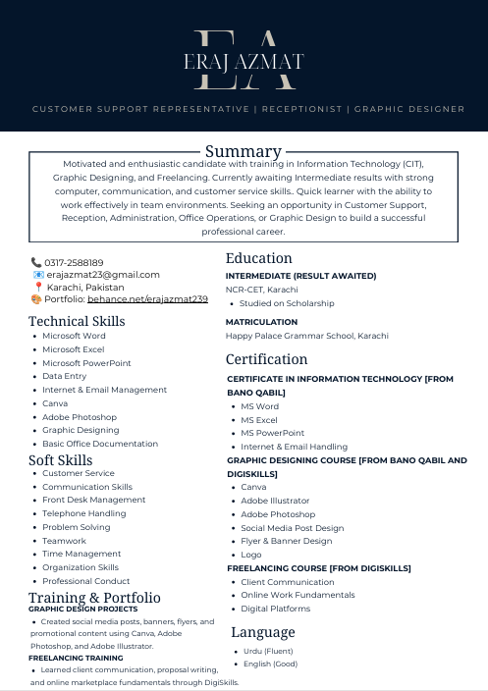
Prompt 3: Cover Letter Writer
Purpose: Generate a cover letter.
Prompt:
Act as an HR expert. Write a professional cover letter for a student applying for a Data Analytics internship.
Output:

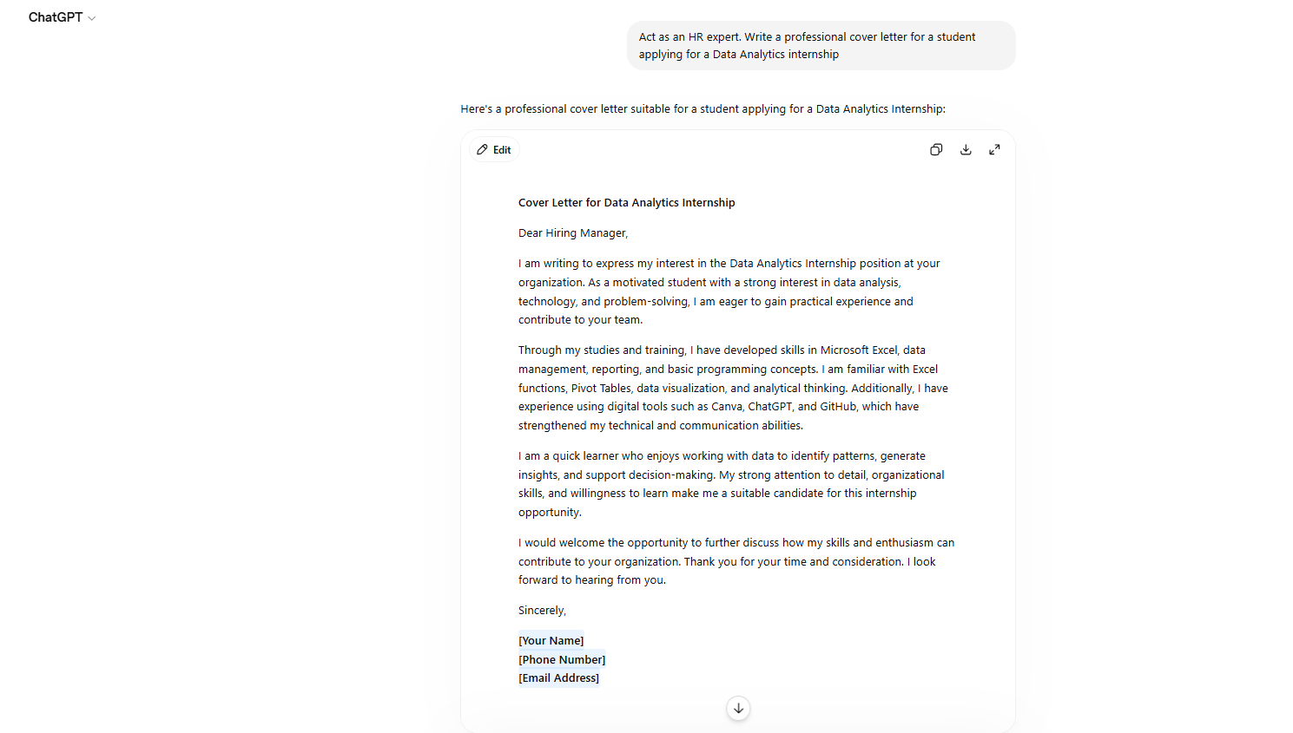
Prompt 4: Learning Roadmap
Purpose: Create a study plan.
Prompt:
Act as a technology mentor. Create a 6-month roadmap to become a Data Analyst, including Excel, SQL, Python, Power BI, and portfolio projects.
Output:
